# 1. Develop a restaurant menu using lists (unordered and ordered list).

# <html >

# <head>

# <title>Royal Grill</title>

# <style>

# body {

# background: linear-gradient(45deg, #ff3e8f, #ffba8f);

# }

# .categories {

# display: grid;

# grid-template-columns: 1fr 1fr;

# }

# .category {

# text-align: left;

# padding-left: 120px;

# }

# .category li {

# display: flex;

# justify-content: space-between;

# }

# </style>

# </head>

# <body>

# <h1 style="text-align: center; font-size:50px;">Royal Grill</h1>

# <h2 style="text-align: center; font-size:40px;">MENU</h2>

# <div class="categories">

# <div class="category">

# <h3>Starters</h3>

# <ul>

# <li>Paneer Tikka<span>Rs 100/-</span></li>

# <li>Baked Kachori<span>Rs 100/-</span></li>

# <li>Hamburger<span>Rs 100/-</span></li>

# <li>Cheese Chicken kebabs<span>Rs 100/-</span></li>

# <li>Chicken 65<span>Rs 100/-</span></li>

# </ul>

# </div>

# <div class="category">

# <h3>Main Course</h3>

# <ul>

# <li>Cauliflower Bolognese <span>Rs 300/-</span></li>

# <li>Grand Aioli<span>Rs 300/-</span></li>

# <li>Clam Toasts with Pancetta<span>Rs 300/-</span></li>

# <li>Spring Risotto<span>Rs 300/-</span></li>

# <li>Chicken Escabeche<span>Rs 300/-</span></li>

# </ul>

# </div>

# <div class="category">

# <h3>Desserts</h3>

# <ul>

# <li>Grilled Doughnut<span>Rs 200/-</span></li>

# <li>Grilled Pineapple Ice-Cream<span>Rs 200/-</span></li>

# <li>Grilled Dessert Nachos<span>Rs 200/-</span></li>

# <li>S'mores Hand Pies<span>Rs 200/-</span></li>

# <li>Toasted Marshmallow<span>Rs 200/-</span></li>

# </ul>

# </div>

# <div class="category">

# <h3>Side Dishes</h3>

# <ul>

# <li>Broccoli Casserole<span>Rs 200/-</span></li>

# <li>Stuffed Grilled Zucchini<span>Rs 200/-</span></li>

# <li>Grilled Cabbage<span>Rs 200/-</span></li>

# <li>Grilled Green Beans<span>Rs 200/-</span></li>

# <li>Barbecued Beans<span>Rs 200/-</span></li>

# </ul>

# </div>

# </div>

# </body>

# </html>

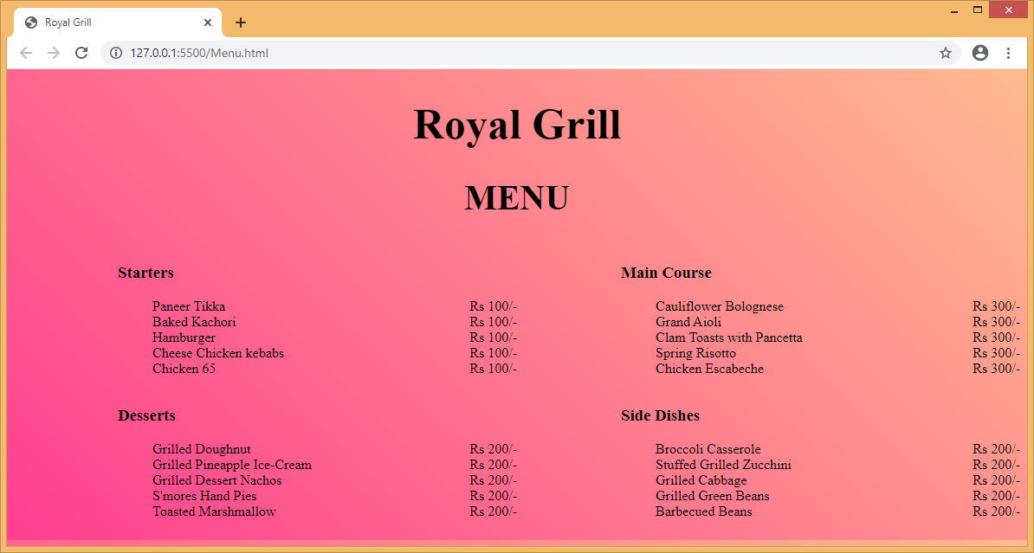

2. Using description list and other list tags develop a restaurant menu that also describes each dish/food item on the menu.

<html lang="en">

<head>

<title>Royal Grill</title>

<style>

body {

background: linear-gradient(45deg, #ff3e8f, #ffba8f);

}

dt {

display: flex;

justify-content: space-between;

}

dd {

margin-bottom: 20px;

}

</style>

</head>

<body>

<h2 style="text-align: center; font-size:40px;">Lunch MENU</h2>

<hr />

<dl>

<dt><b>Zesty Salmon filet</b><span>Rs 200/-</span></dt>

<dd>

Oven-baked salmon filet served with a <br />

garlic-infused citrusy sauce. Kosher product.

</dd>

<dt><b>Glazed Lamb Chops</b><span>Rs 200/-</span></dt>

<dd>

Slow cooked lamb chops marinated with garlic and <br />

paprika with balsamic vinegar reduction. Halal product.

</dd>

<dt><b>Hummus mezze</b><span>Rs 200/-</span></dt>

<dd>

An assortment of 4 hummus plates: plain, with avocado, <br />

with paprika and with truffle oil. Vegan Friendly.

</dd>

<dt><b>Cheese Burger</b><span>Rs 200/-</span></dt>

<dd>

Freshly ground, grass-fed beef, locally sourced and <br />

served in a burger bun with melted cheese, tomato and burger sauce.

</dd>

<dt><b>Heavenly Oreo</b><span>Rs 200/-</span></dt>

<dd>

baked cheesecake with chocolate and hazelnut.

</dd>

<dt><b>Redneck Pulled Pork</b><span>Rs 200/-</span></dt>

<dd>

Slow cooked, hand-pulled juicy pork meat piled high a fresh bun, topped

<br />

with homemade coleslaw and chef Bob's special BBQ sauce.

</dd>

</dl>

</body>

</html>

